**PROJECT**

**Avinash Reddy Madireddy – 926067606**

**Tanvitha Koganti-928591074**

**Honor Pledge**

On the cover page of your project report, please type/write down the following sentence in the underlined section below and sign/type your name under it.



Do NOT copy and paste the sentence, please do type/write every word in this sentence. Failure to write down this sentence and sign your name or failure to honor the content of this sentence will result in 0 points in the project.

Write the above sentence in the underlined section below:

“On my honor, I have neither given nor received unauthorized aid on this project.”

Type or Sign Your Name here:

Avinash Reddy Madireddy

Tanvitha koganti

**PSU ID:**



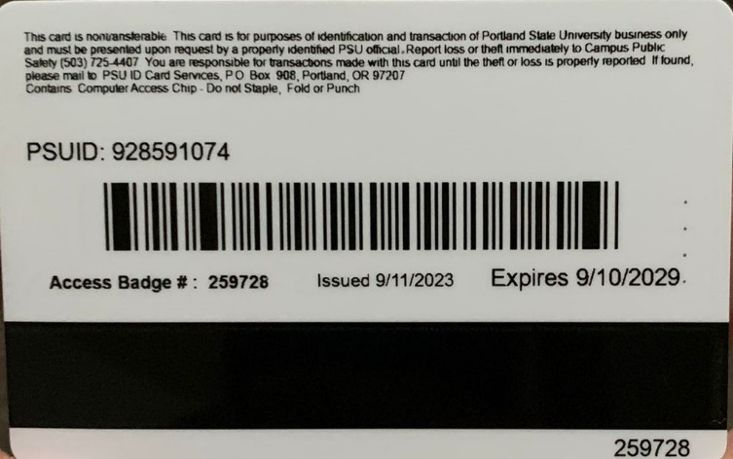

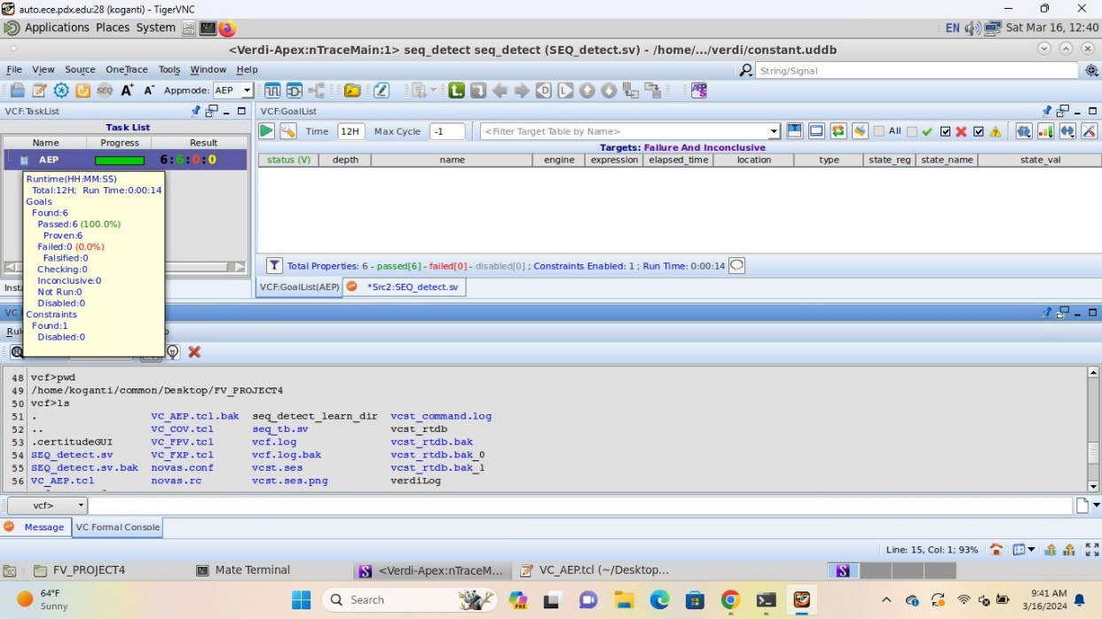**VC FORMAL AEP**

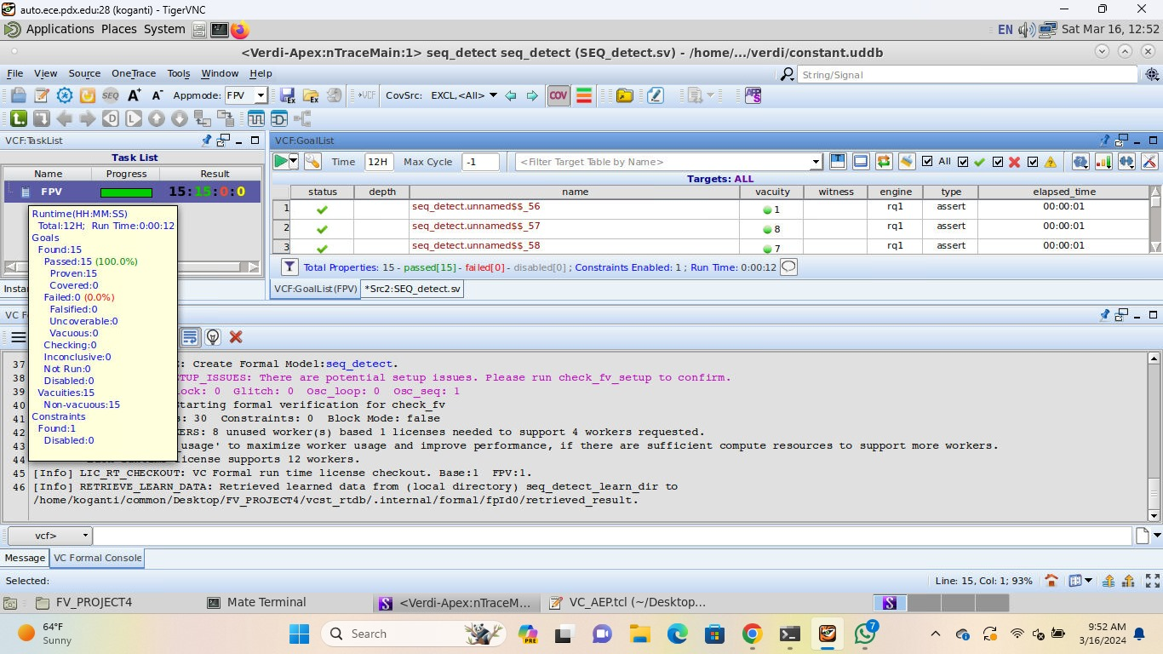**VC FORMAL FPV**

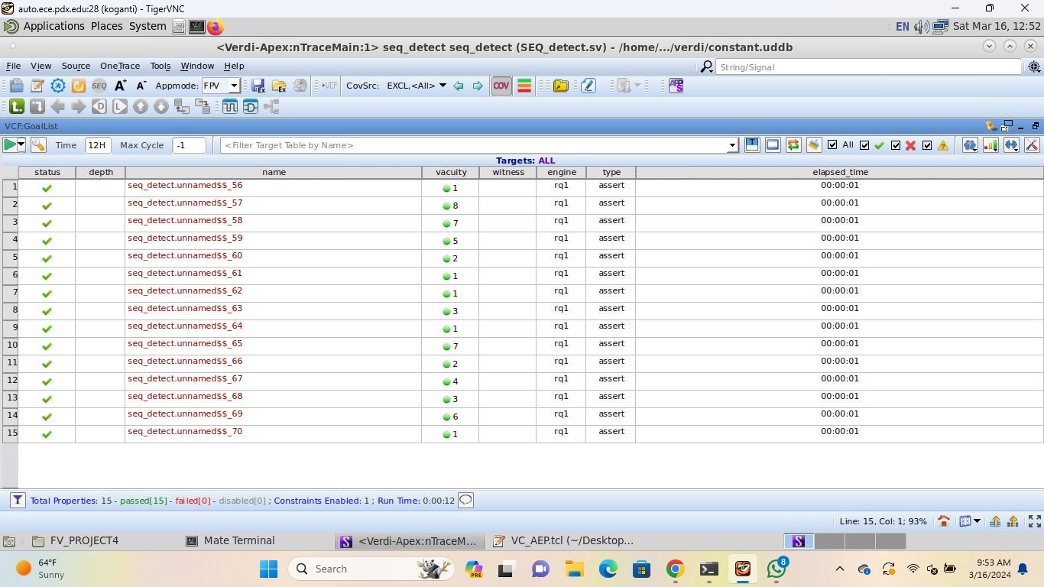

**VC FORMAL COV**

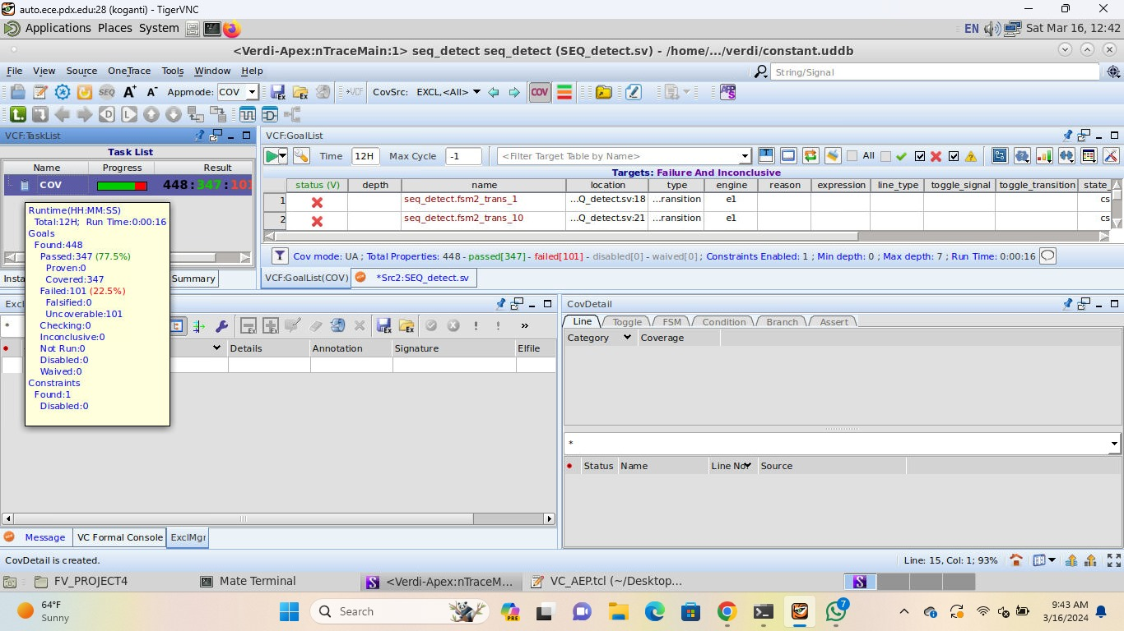

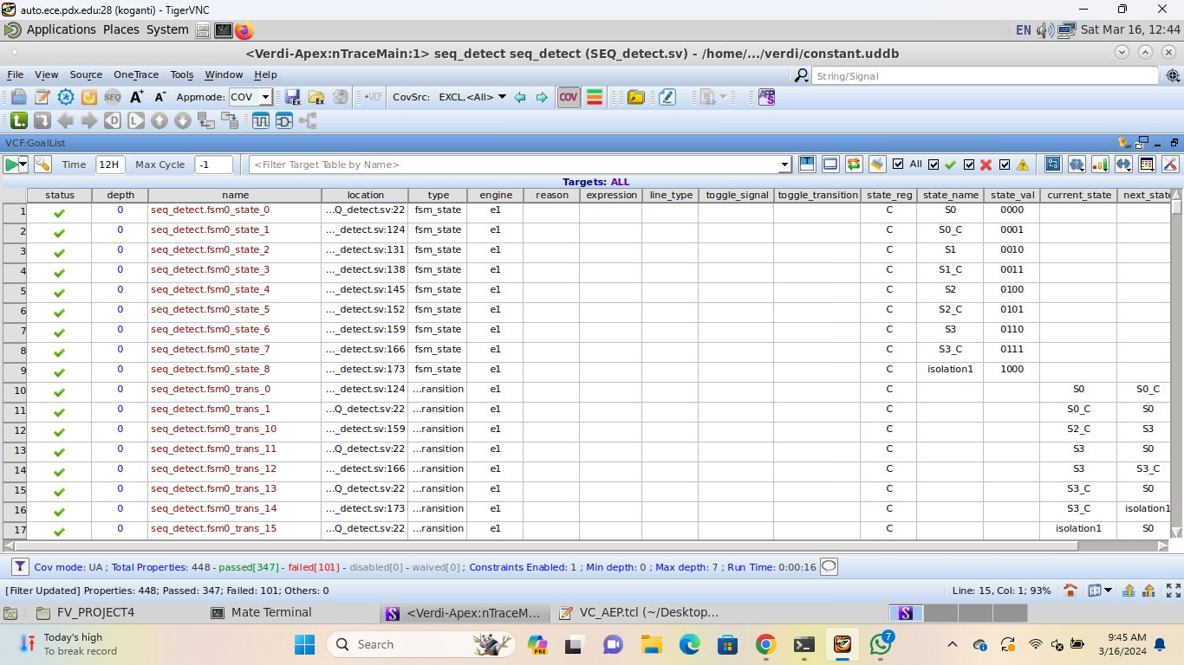

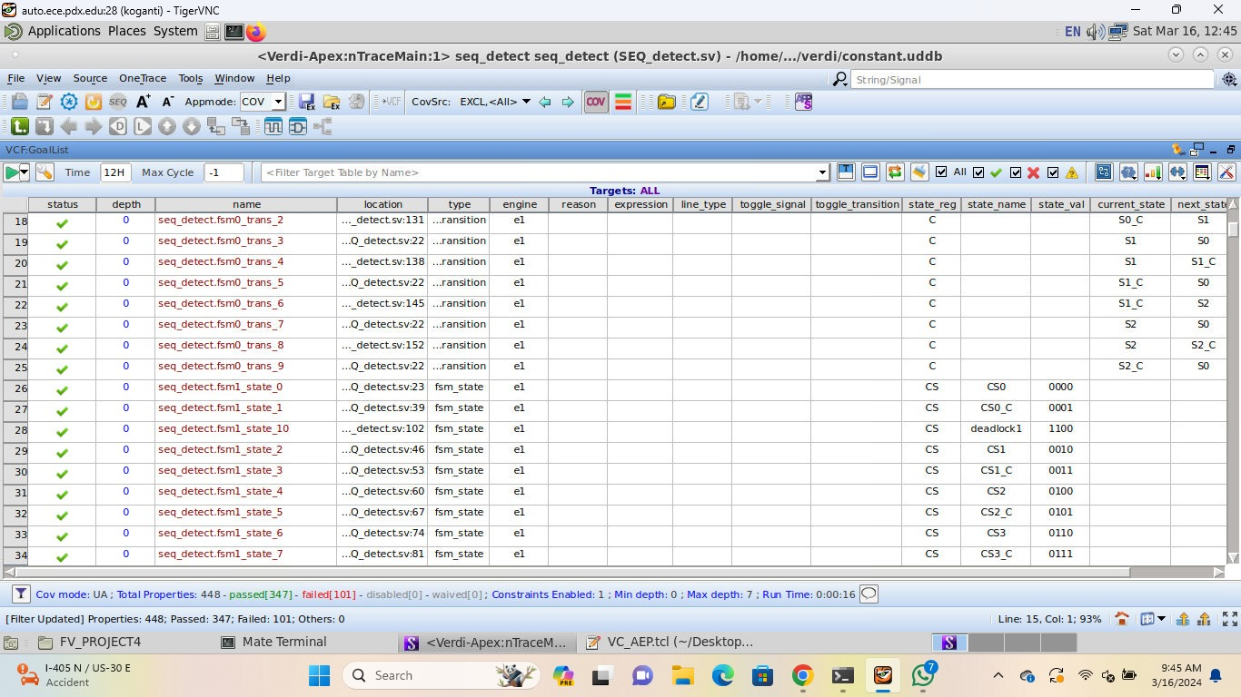

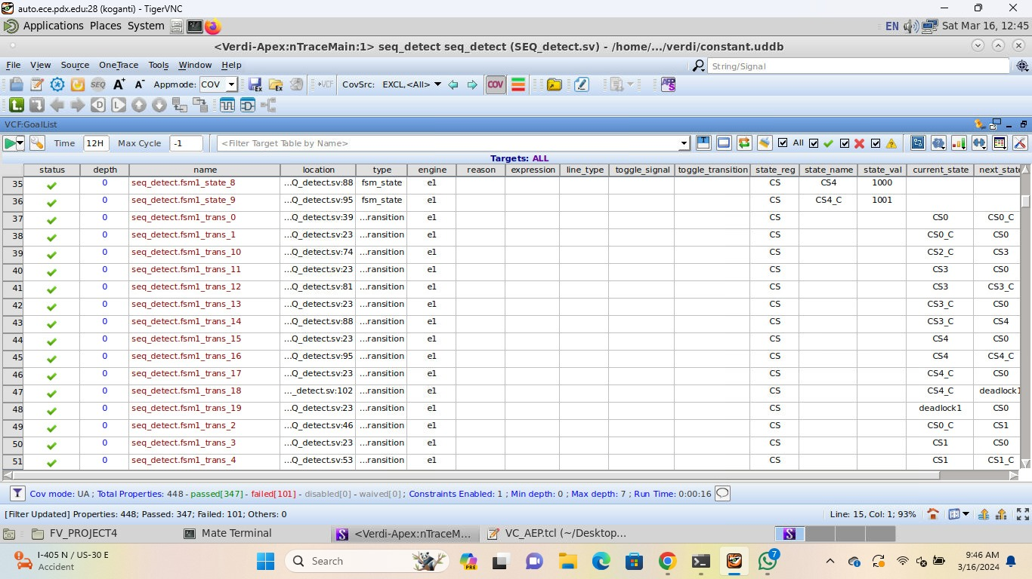

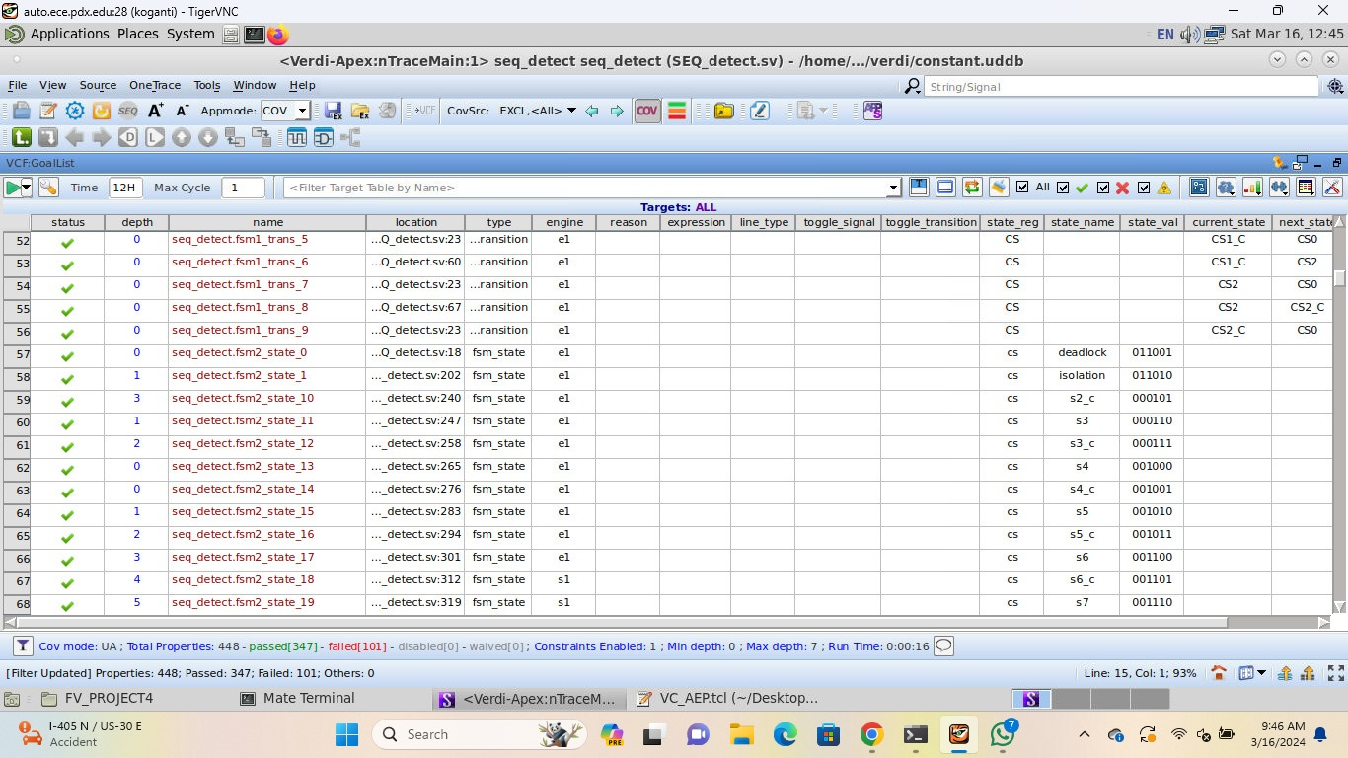

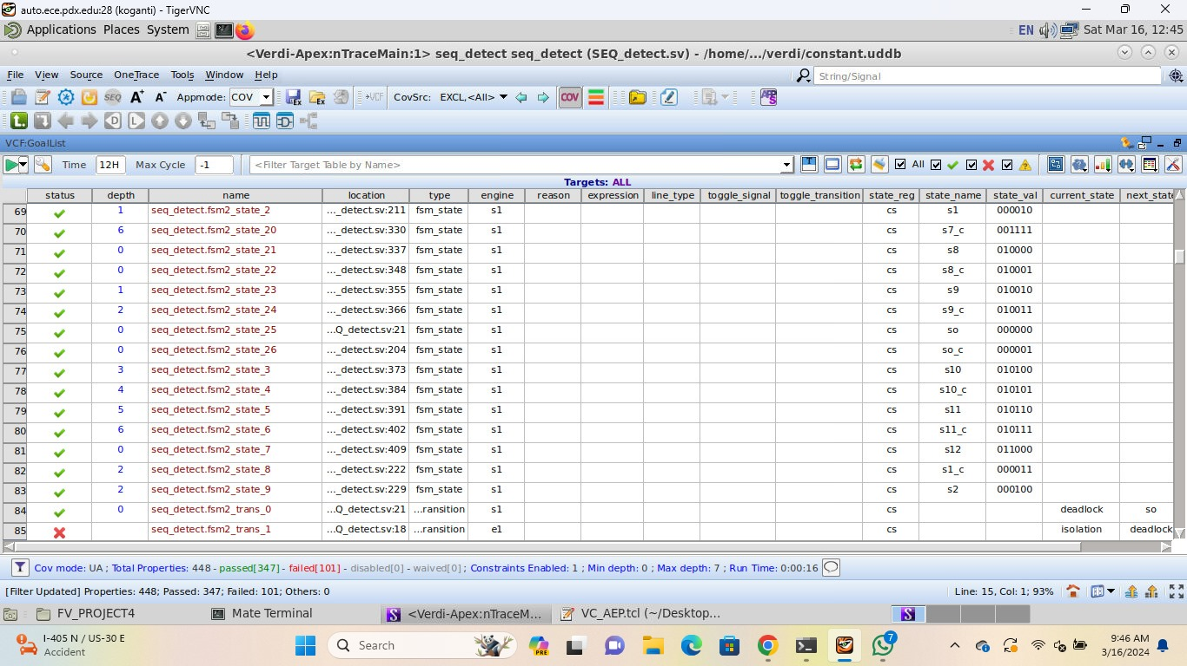

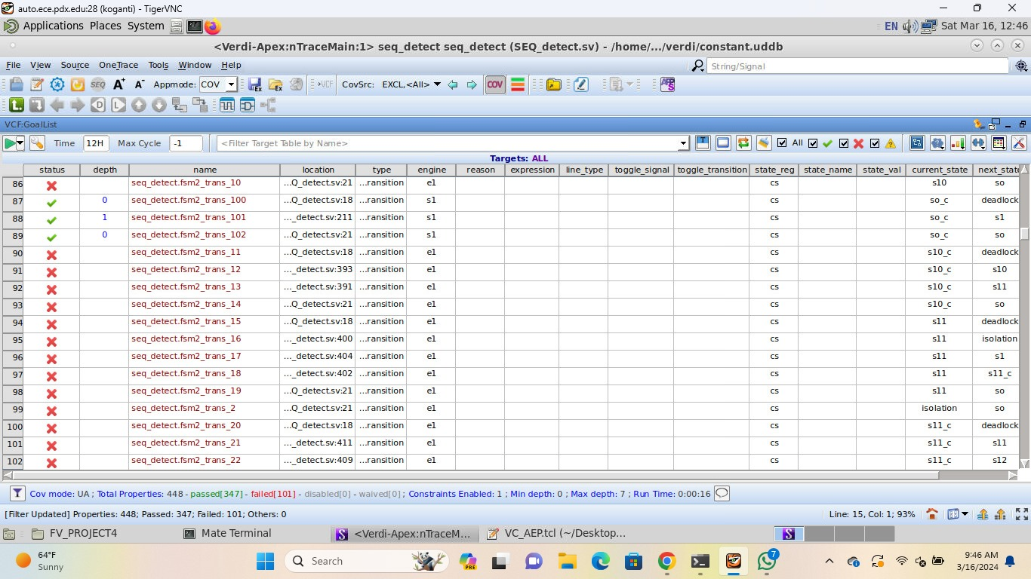

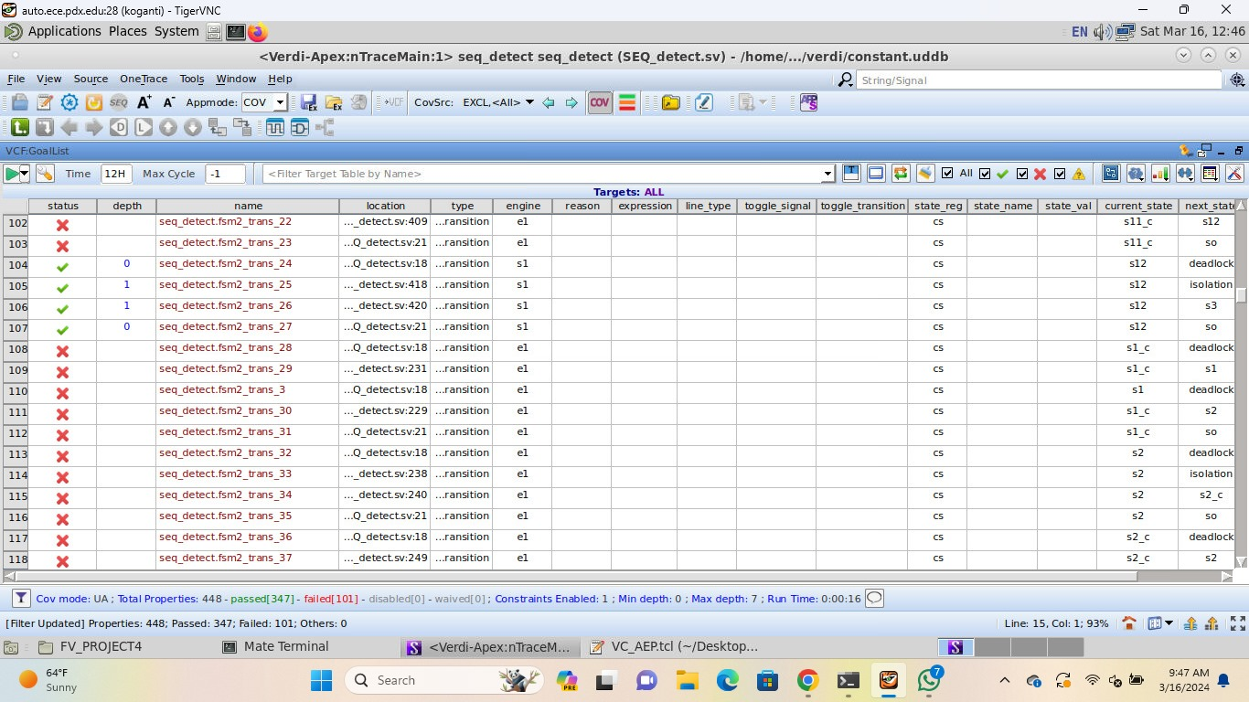

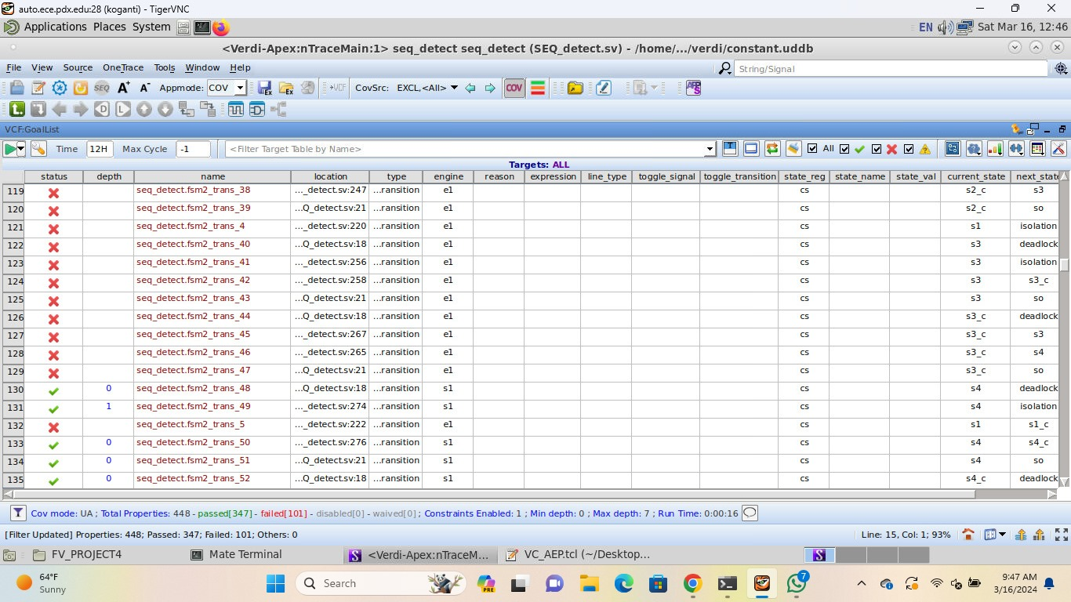

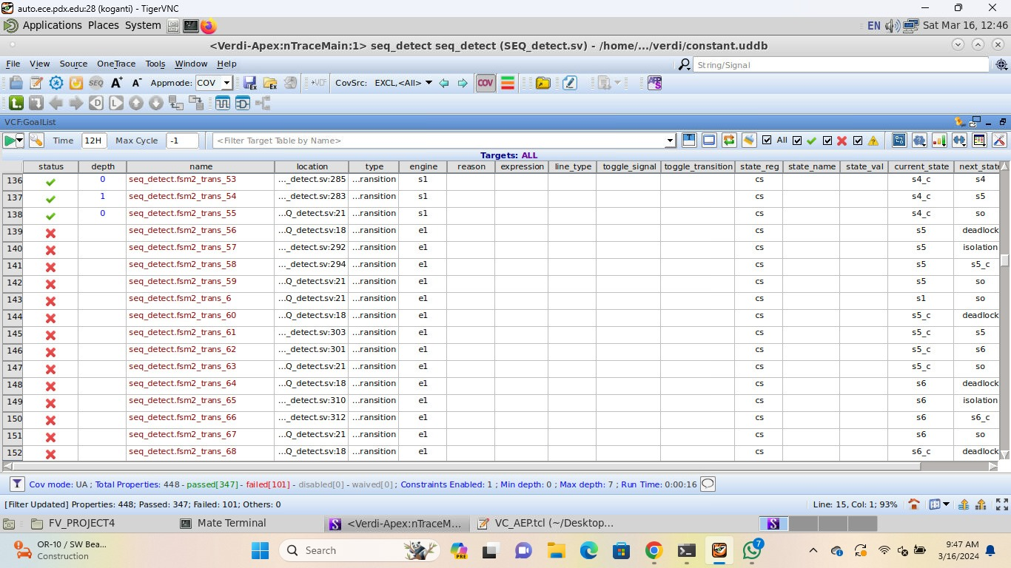

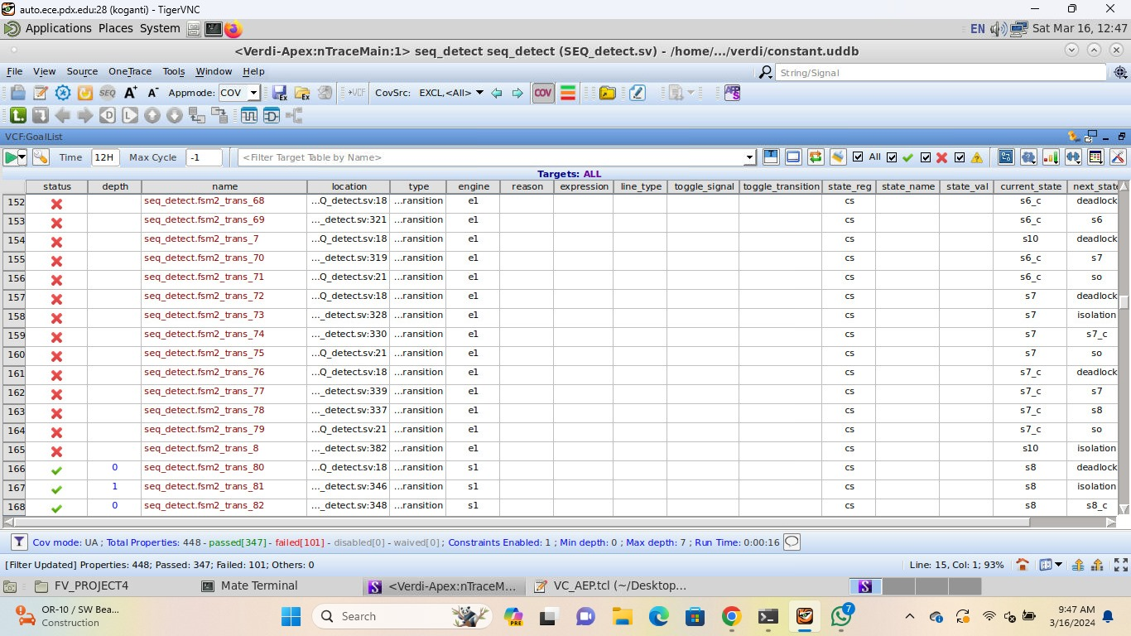

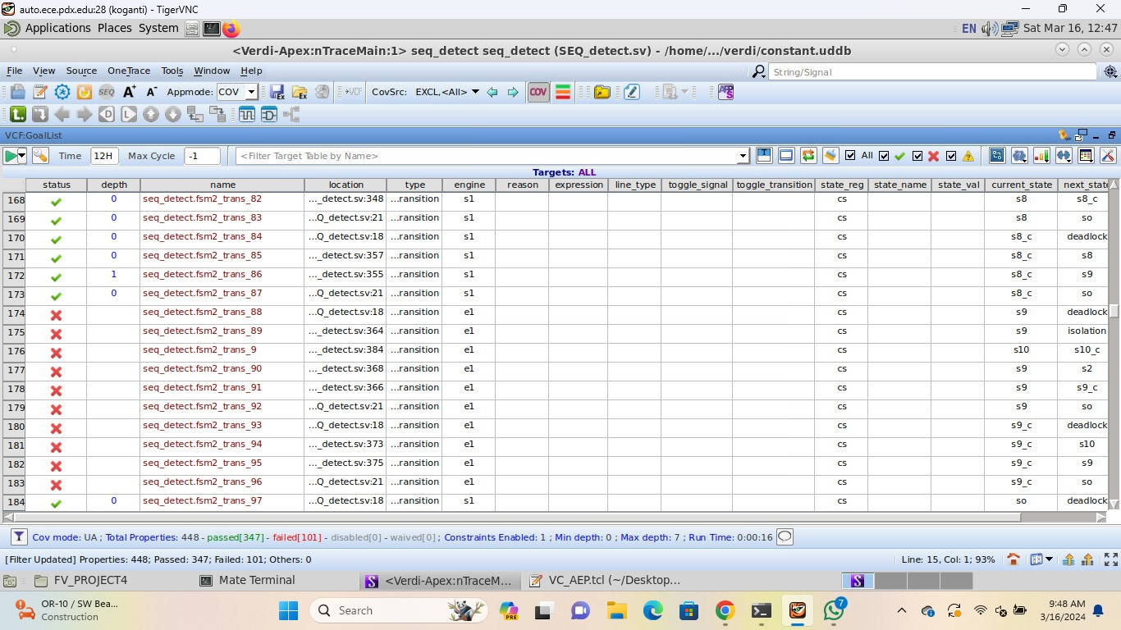

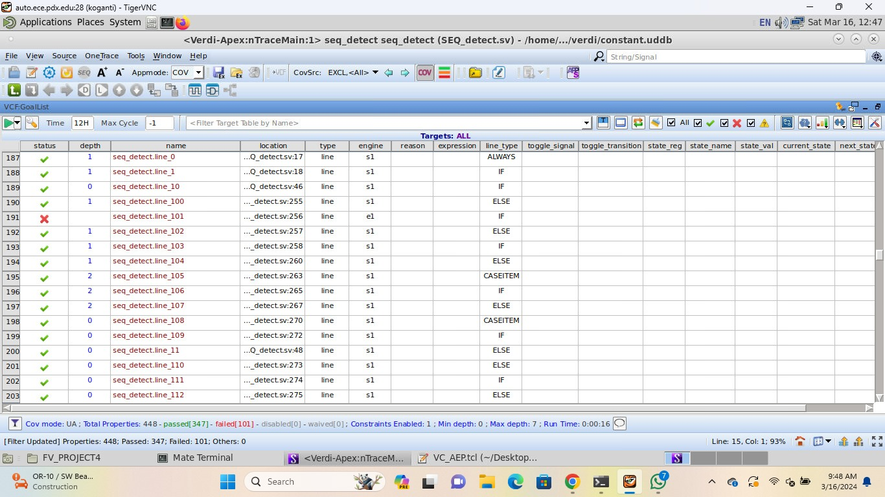

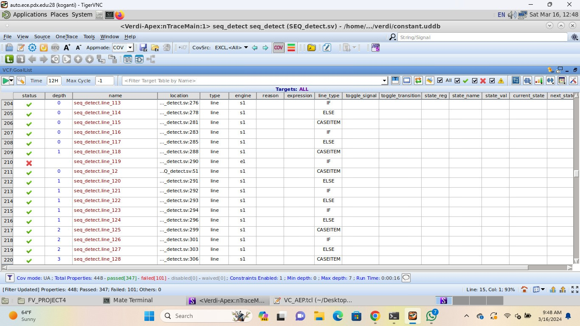

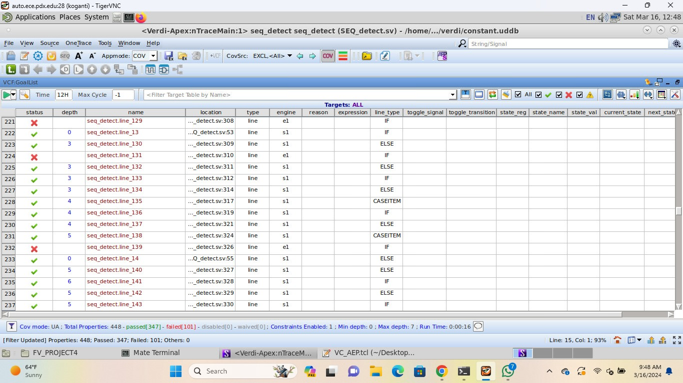

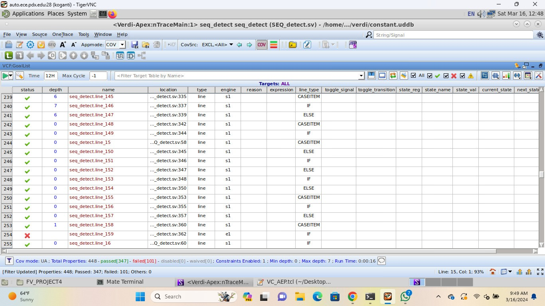

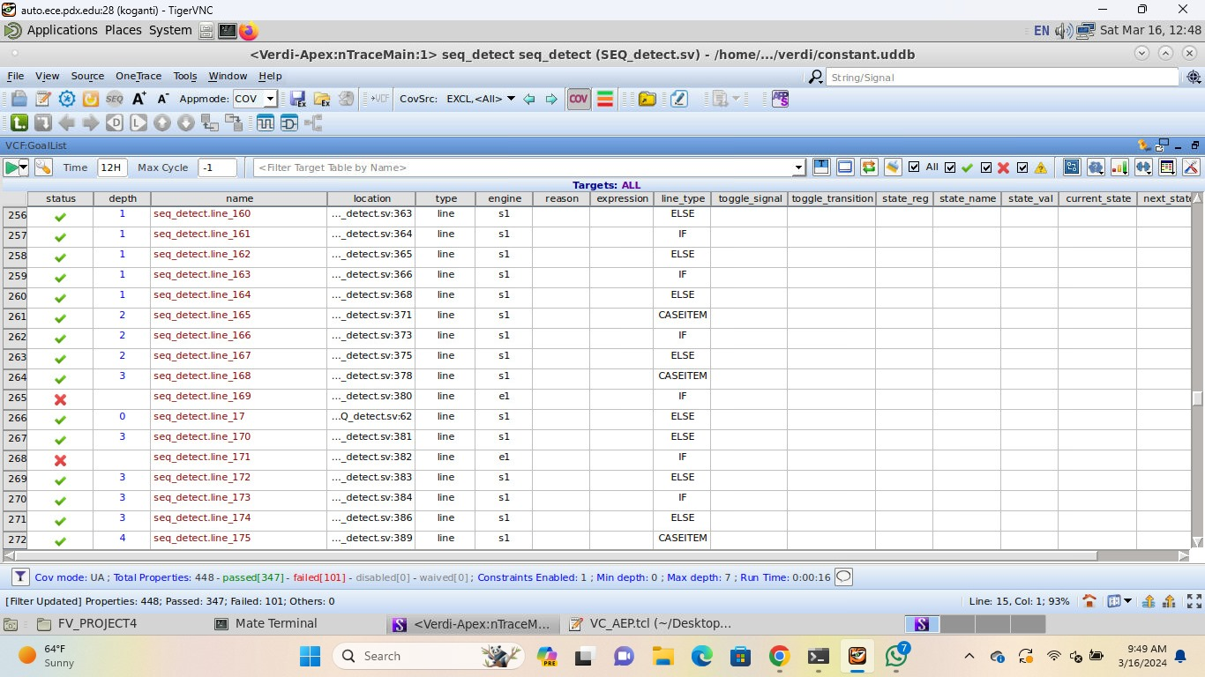

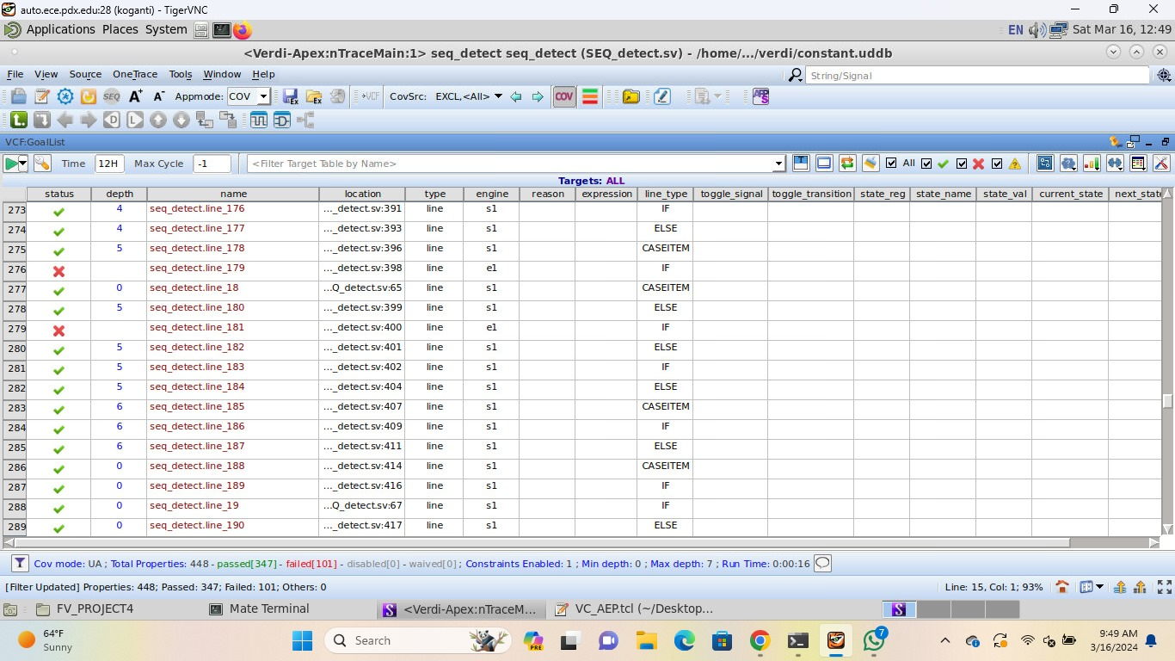

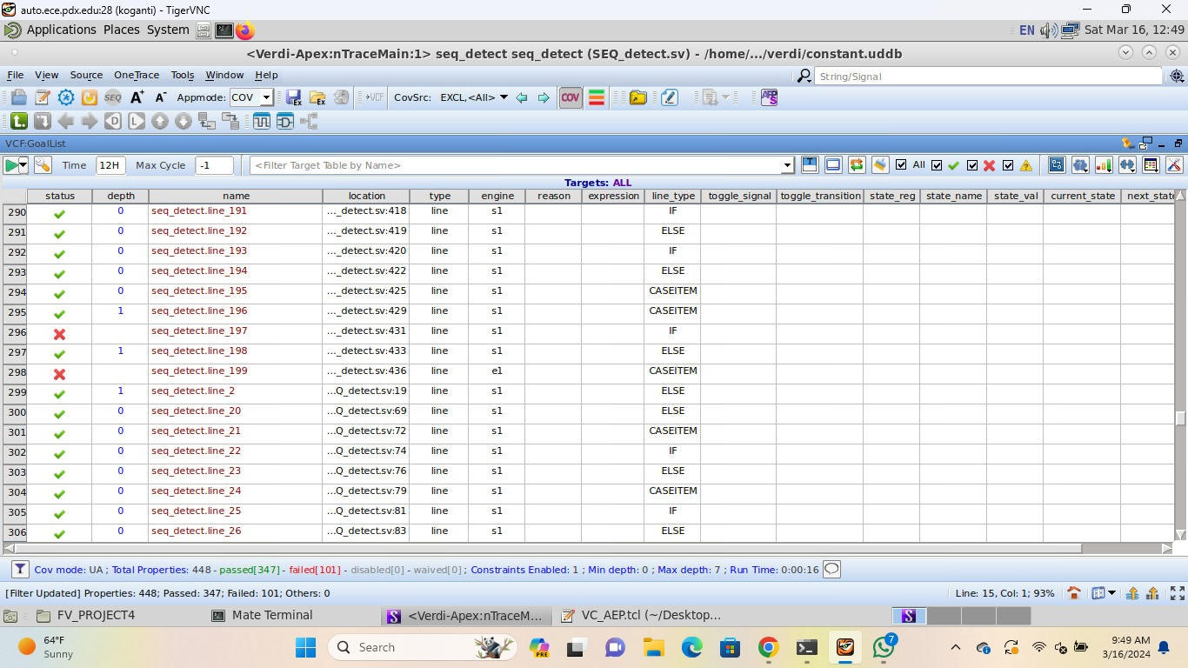

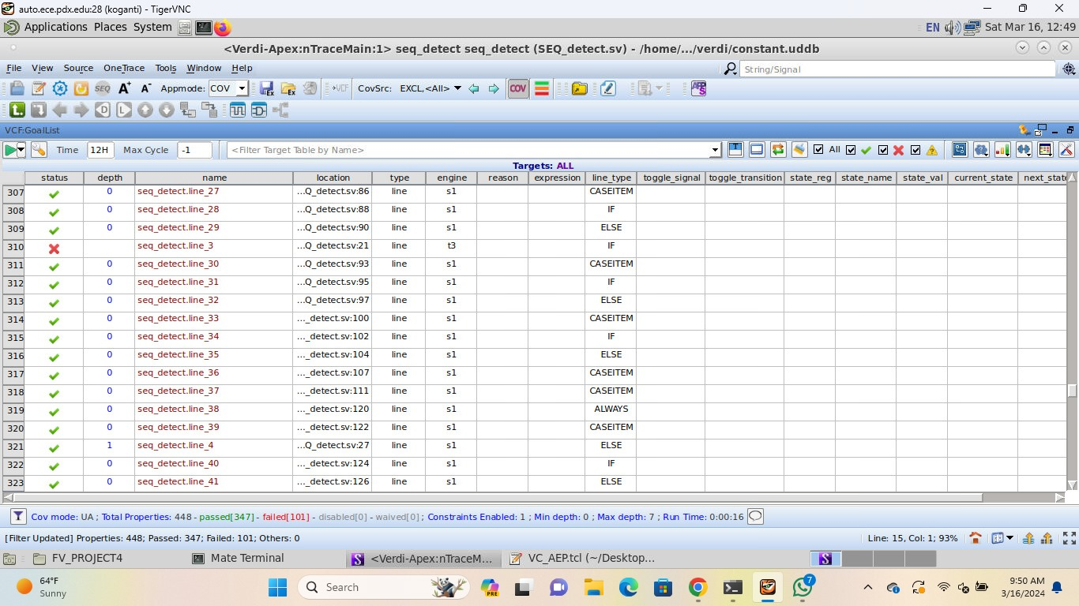

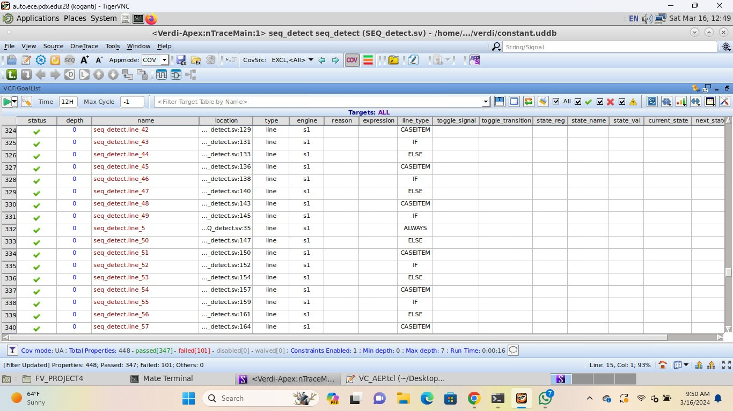

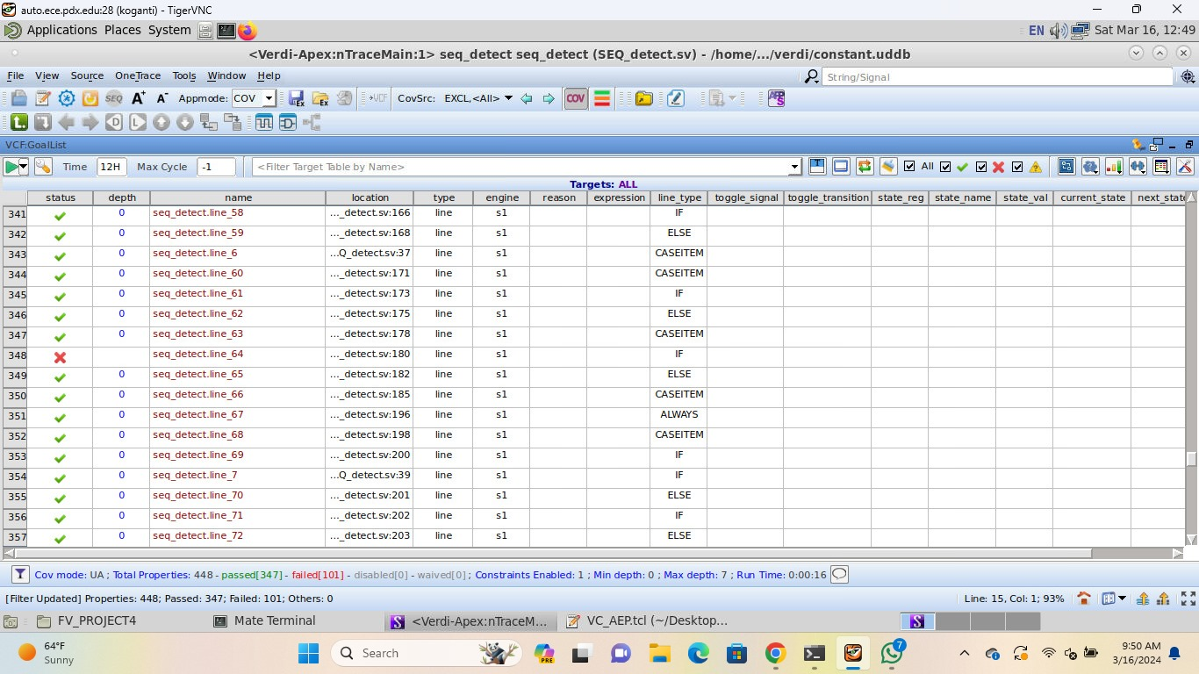

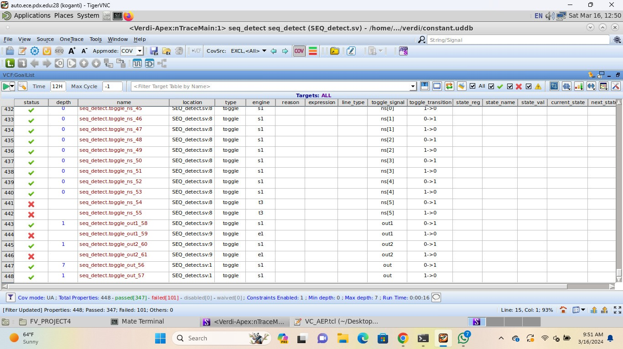

**VC FORMAL FXP**

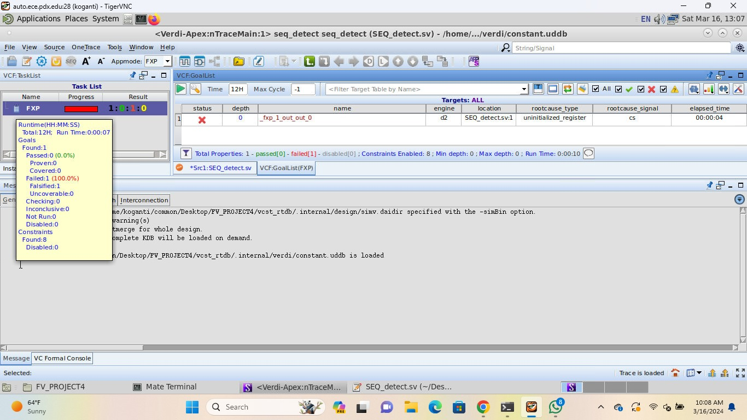

Comments: we have taken care of all the cases we have known for instance: Avoiding unwanted latches, no cases of unknowns for all the variables and ports, included unique cases as well as default statements but couldn't get the output which pass all the cases.

**WAVEFORM for sequence detection**

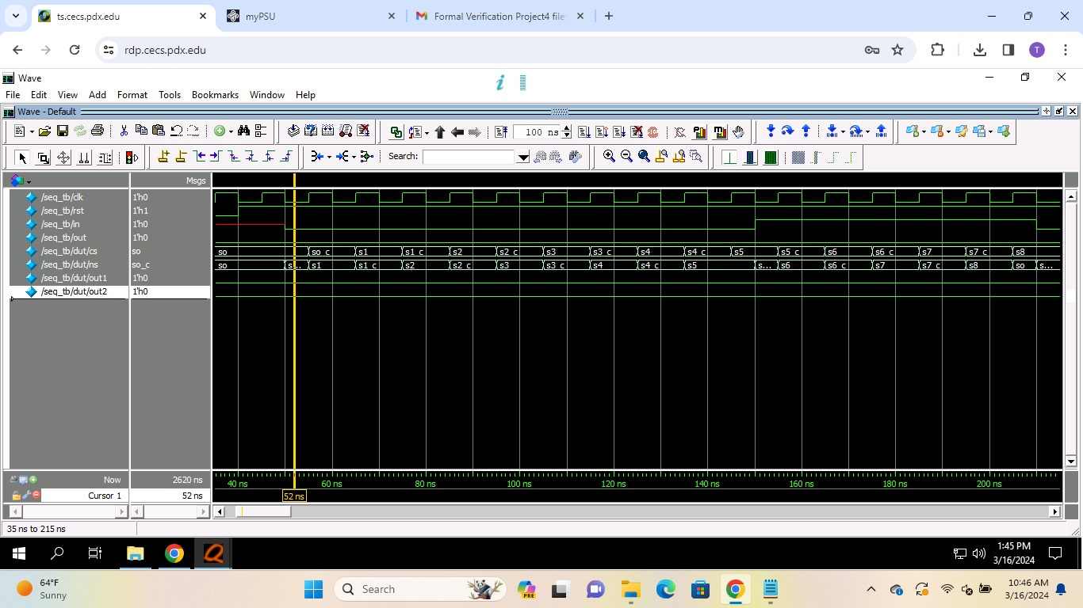

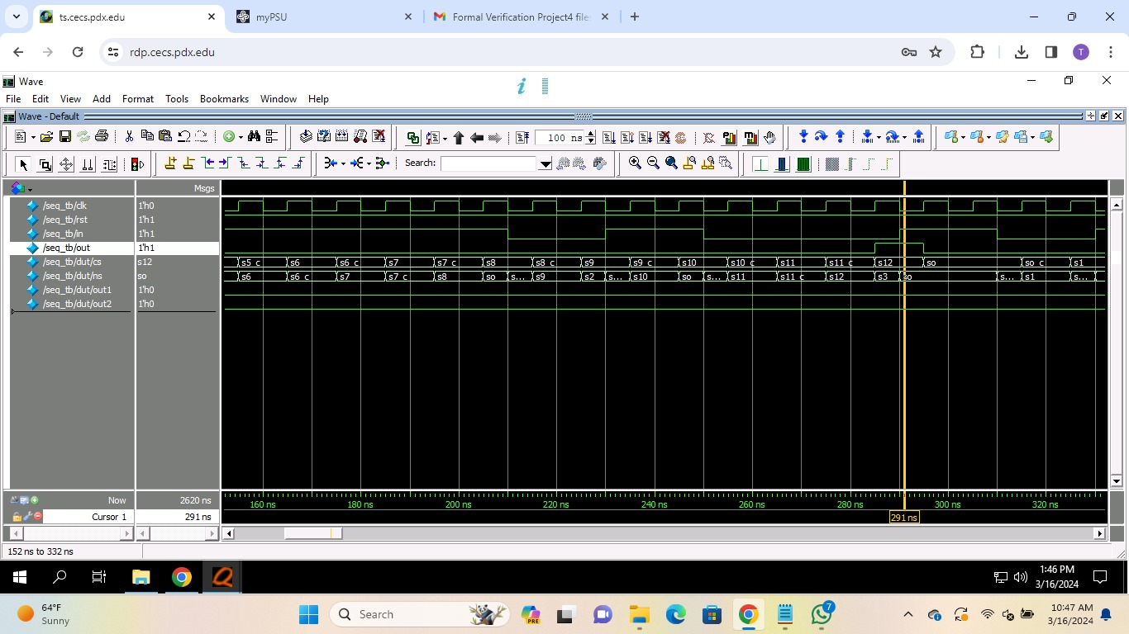

**WAVEFORM FOR DEADLOCK**

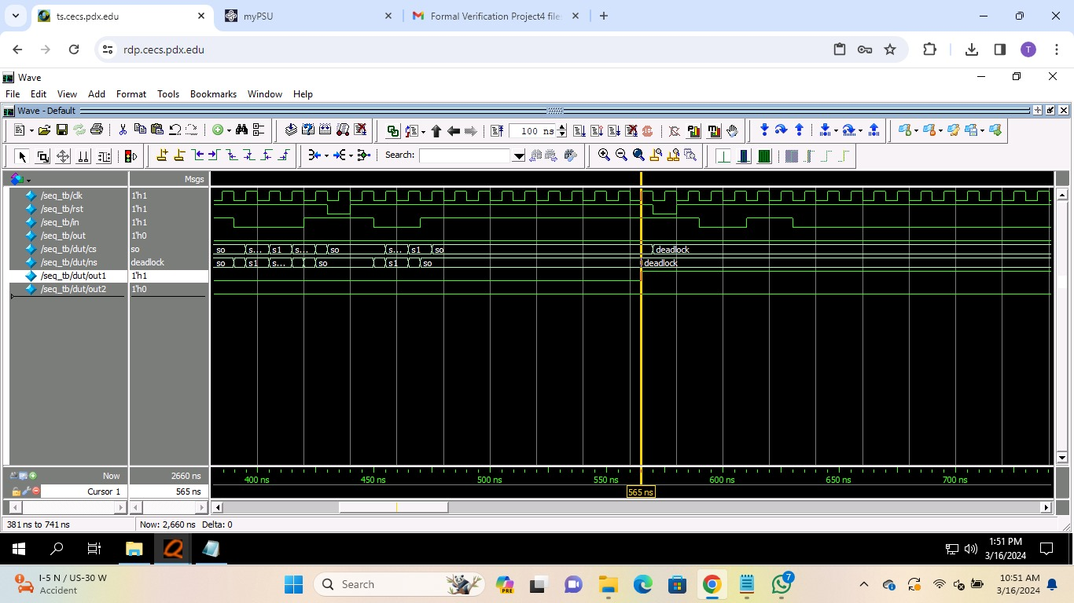

**WAVEFORM FOR ISOLATION**

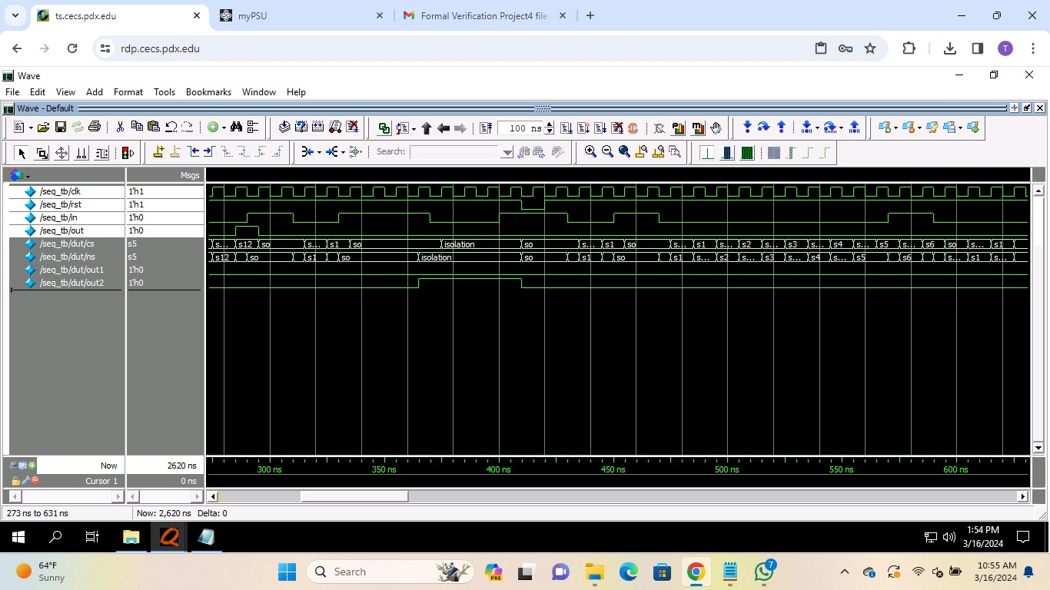

**FSM:**

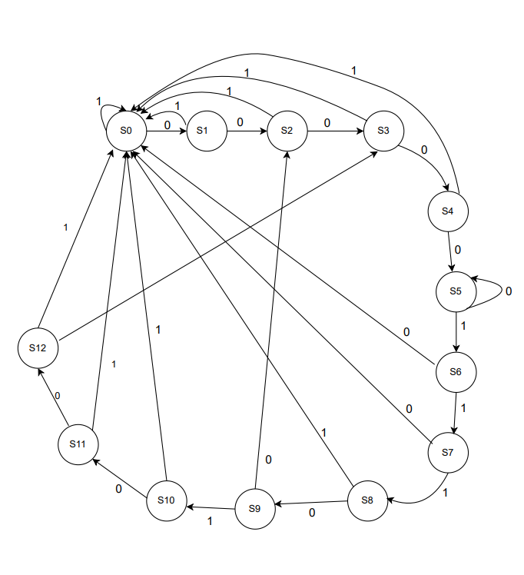

**FSM with check states:**

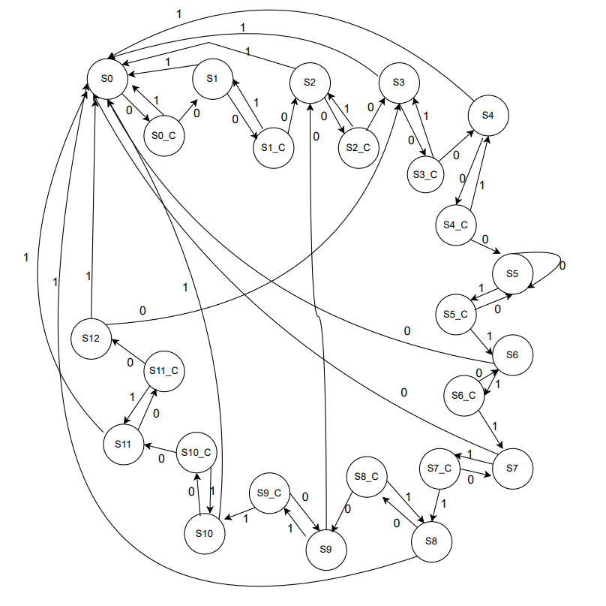

**FSM deadlock:**

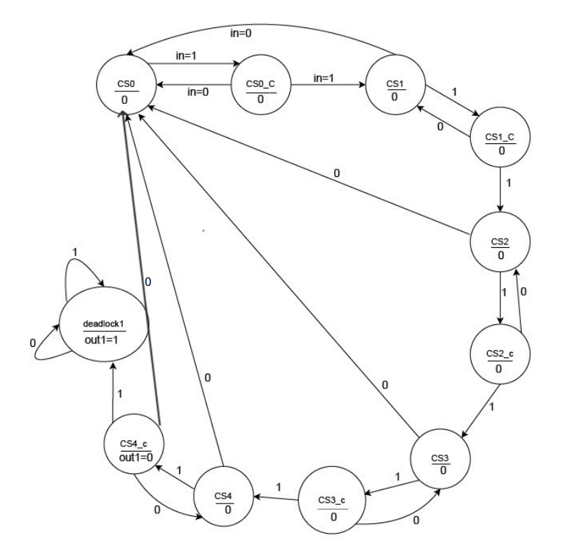

**FSM isolation:**

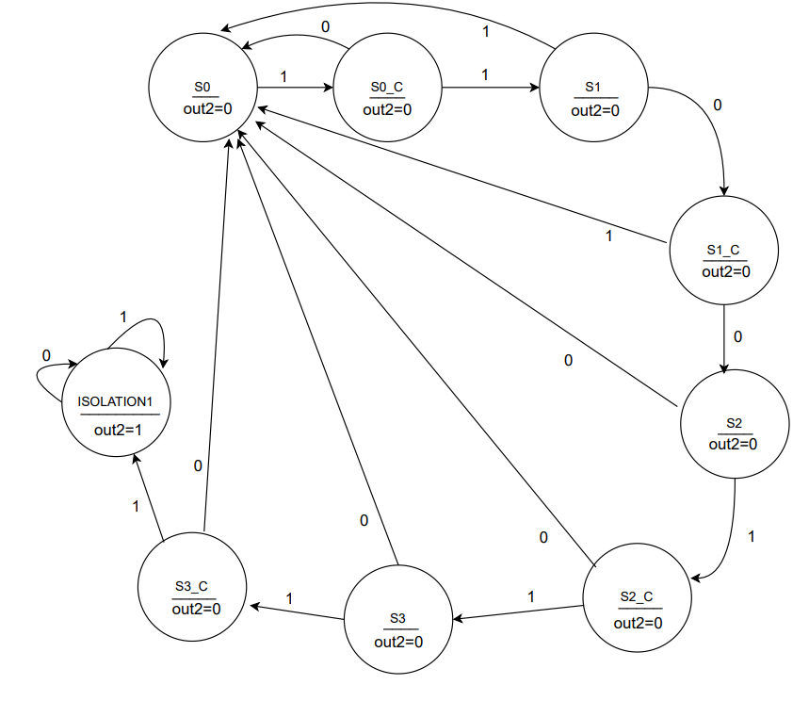

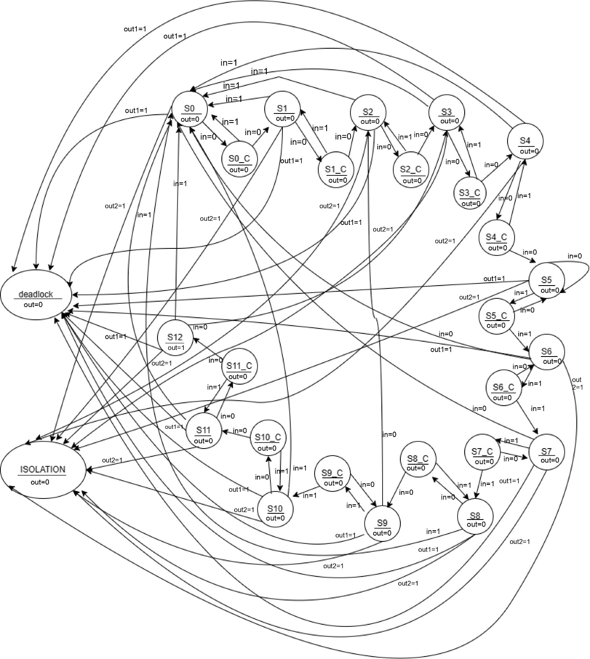

**System Verilog code for Sequence detector:**

module seq_detect(input logic clk,rst,in,output logic out);

typedef enum logic [4:0]{so,so_c,s1,s1_c,s2,s2_c,s3,s3_c,s4,s4_c,s5,s5_c,s6,s6_c,s7,s7_c,s8,s8_c,s9,s9_c,s10,s10_c,

s11,s11_c,s12,deadlock,isolation}state;

typedef enum logic [3:0]{S0,S0_C,S1,S1_C,S2,S2_C,S3,S3_C,isolation1}st;

typedef enum logic [3:0]{CS0,CS0_C,CS1,CS1_C,CS2,CS2_C,CS3,CS3_C,CS4,CS4_C,CS5,CS5_C,deadlock1}sta;

sta NS,CS;

st N,C;

state cs,ns;

logic out1,out2;

//sequence:0000 0111 0100

//deadlock sequence:11111

//isolation sequence:1011

always_ff@(posedge clk or negedge rst)

begin

if(out1)

cs <= deadlock;

else if(!rst)

begin

cs <= so;

C <= S0;

CS <= CS0;

end

else

begin

cs <= ns;

C <= N;

CS <= NS;

end

end

always_comb

begin

out1 = 1'b0;

NS = CS;

unique case(CS)

CS0 : begin

out1 = 1'b0;

if(in)

NS = CS0_C;

else

NS = CS0;

end

CS0_C : begin

out1 = 1'b0;

if(in)

NS = CS1;

else

NS = CS0;

end

CS1 : begin

out1 = 1'b0;

if(in)

NS = CS1_C;

else

NS = CS0;

end

CS1_C : begin

out1 = 1'b0;

if(in)

NS = CS2;

else

NS = CS0;

end

CS2 : begin

out1 = 1'b0;

if(in)

NS = CS2_C;

else

NS = CS0;

end

CS2_C : begin

out1 = 1'b0;

if(in)

NS = CS3;

else

NS = CS0;

end

CS3 : begin

out1 = 1'b0;

if(in)

NS = CS3_C;

else

NS = CS0;

end

CS3_C : begin

out1 = 1'b0;

if(in)

NS = CS4;

else

NS = CS0;

end

CS4 : begin

out1 = 1'b0;

if(in)

NS = CS4_C;

else

NS = CS0;

end

CS4_C : begin

out1 = 1'b0;

if(in)

NS = deadlock1;

else

NS = CS0;

end

deadlock1 : begin

NS = deadlock1;

out1 = 1'b1;

end

default : begin

NS = CS;

out1 = 1'b0;

end

endcase

end

//assign out1 = (CS==deadlock1) ? 1'b1 : 1'b0;

always_comb

begin

out2 = 1'b0;

N = C;

unique case(C)

S0 : begin

out2 = 1'b0;

if(in)

N = S0_C;

else

N = S0;

end

S0_C : begin

out2 = 1'b0;

if(in)

N = S1;

else

N = S0;

end

S1 : begin

out2 = 1'b0;

if(!in)

N = S1_C;

else

N = S0;

end

S1_C : begin

out2 = 1'b0;

if(!in)

N = S2;

else

N = S0;

end

S2 : begin

out2 = 1'b0;

if(in)

N = S2_C;

else

N = S0;

end

S2_C :begin

out2 = 1'b0;

if(in)

N = S3;

else

N = S0;

end

S3 : begin

out2 = 1'b0;

if(in)

N = S3_C;

else

N = S0;

end

S3_C : begin

out2 = 1'b0;

if(in)

N = isolation1;

else

N = S0;

end

isolation1 : begin

out2 = 1'b1;

if(!rst)

N = S0;

else

N = isolation1;

end

default : begin

N = C;

out2 = 1'b0;

end

endcase

end

//assign out2 = (C==isolation1) ? 1'b1 : 1'b0;

always_comb

begin

out = 1'b0;

ns = cs;

unique case(cs)

so : begin

out = 1'b0;

if(out1)

ns = deadlock;

else if(out2)

ns = isolation;

else if(!in)

ns = so_c;

else

ns = so;

end

so_c : begin

out = 1'b0;

if(!in)

ns = s1;

else

ns = so;

end

s1 : begin

out = 1'b0;

if(out1)

ns = deadlock;

else if(out2)

ns = isolation;

else if(!in)

ns = s1_c;

else

ns = so;

end

s1_c : begin

out = 1'b0;

if(!in)

ns = s2;

else

ns = s1;

end

s2 : begin

out = 1'b0;

if(out1)

ns = deadlock;

else if(out2)

ns = isolation;

else if(!in)

ns = s2_c;

else

ns = so;

end

s2_c : begin

out = 1'b0;

if(!in)

ns = s3;

else

ns = s2;

end

s3 : begin

out = 1'b0;

if(out1)

ns = deadlock;

else if(out2)

ns = isolation;

else if(!in)

ns = s3_c;

else

ns = so;

end

s3_c : begin

out = 1'b0;

if(!in)

ns = s4;

else

ns = s3;

end

s4 : begin

out = 1'b0;

if(out1)

ns = deadlock;

else if(out2)

ns = isolation;

else if(!in)

ns = s4_c;

else

ns = so;

end

s4_c : begin

out = 1'b0;

if(!in)

ns = s5;

else

ns = s4;

end

s5 : begin

out = 1'b0;

if(out1)

ns = deadlock;

else if(out2)

ns = isolation;

else if(in)

ns = s5_c;

else

ns = s5;

end

s5_c : begin

out = 1'b0;

if(in)

ns = s6;

else

ns = s5;

end

s6 : begin

out = 1'b0;

if(out1)

ns = deadlock;

else if(out2)

ns = isolation;

else if(in)

ns = s6_c;

else

ns = so;

end

s6_c : begin

out = 1'b0;

if(in)

ns = s7;

else

ns = s6;

end

s7 : begin

out = 1'b0;

if(out1)

ns = deadlock;

else if(out2)

ns = isolation;

else if(in)

ns = s7_c;

else

ns = so;

end

s7_c : begin

out = 1'b0;

if(in)

ns = s8;

else

ns = s7;

end

s8 : begin

out = 1'b0;

if(out1)

ns = deadlock;

else if(out2)

ns = isolation;

else if(!in)

ns = s8_c;

else

ns = so;

end

s8_c : begin

out = 1'b0;

if(!in)

ns = s9;

else

ns = s8;

end

s9 : begin

out = 1'b0;

if(out1)

ns = deadlock;

else if(out2)

ns = isolation;

else if(in)

ns = s9_c;

else

ns = s2;

end

s9_c : begin

out = 1'b0;

if(in)

ns = s10;

else

ns = s9;

end

s10 : begin

out = 1'b0;

if(out1)

ns = deadlock;

else if(out2)

ns = isolation;

else if(!in)

ns = s10_c;

else

ns = so;

end

s10_c : begin

out = 1'b0;

if(!in)

ns = s11;

else

ns = s10;

end

s11 : begin

out = 1'b0;

if(out1)

ns = deadlock;

else if(out2)

ns = isolation;

else if(!in)

ns = s11_c;

else

ns = s1;

end

s11_c : begin

out = 1'b0;

if(!in)

ns = s12;

else

ns = s11;

end

s12 : begin

out = 1'b1;

if(out1)

ns = deadlock;

else if(out2)

ns = isolation;

else if(!in)

ns = s3;

else

ns = so;

end

deadlock : begin

out = 1'b0;

ns = deadlock;

end

isolation : begin

out = 1'b0;

if(!rst)

ns = so;

else

ns = isolation;

end

default : begin

ns = cs;

out = 1'b0;

end

endcase

end

//assign out = (cs==s12) ? 1'b1 : 1'b0;

`ifdef tanvitha

assert property(

@(posedge clk) (cs == s12) |-> (out == 1)); //1

assert property(

@(posedge clk) (cs == s3 && in == 1) |-> (ns == so)); //2

assert property(

@(posedge clk) (cs == s2_c && in == 0) |-> (ns == s3)); //3

assert property(

@(posedge clk) (cs == s6 && in == 1) |-> (ns == s6_c)); //4

assert property(

@(posedge clk) (cs == s3 && in == 0) |-> (ns == s3_c)); //5

assert property(

@(posedge clk) (cs == s4_c && in == 0) |-> (ns == s5)); //6

assert property(

@(posedge clk) (cs == s4_c && in == 1) |-> (ns == s4)); //7

assert property(

@(posedge clk) (cs == s3_c && in == 0) |-> (ns == s4)); //8

assert property(

@(posedge clk) (cs == deadlock && !($isunknown(in)) |-> (ns == deadlock))); //9

assert property(

@(posedge clk) (cs == s7_c && in == 1) |-> (ns == s8)); //10

assert property(

@(posedge clk) (cs == isolation && !($isunknown(in)) |-> (ns == isolation))); //11

assert property(

@(posedge clk) (cs == s5_c && in == 1) |-> (ns == s6)); //12

assert property(

@(posedge clk) (cs == s9_c && in == 1) |-> (ns == s10)); //13

assert property(

@(posedge clk) (cs == s11 && in == 0) |-> (ns == s11_c)); //14

assert property(

@(posedge clk) (cs == s8_c && in == 0) |-> (ns == s9)); //15

`endif

Endmodule

**Testbench code:**

**module seq_tb;**

**logic clk=1'b0;**

**logic rst=1'b1;**

**logic in;**

**logic out;**

**seq_detect dut(clk,rst,in,out);**

**always forever #5 clk = ~clk;**

**initial**

**begin**

**@(negedge clk);**

**@(negedge clk);**

**@(negedge clk) rst = 1'b0;**

**@(negedge clk) rst = 1'b1;**

**@(negedge clk) in = 1'b0;**

**@(negedge clk) in = 1'b0;**

**@(negedge clk) in = 1'b0;**

**@(negedge clk) in = 1'b0;**

**@(negedge clk) in = 1'b0;**

**@(negedge clk) in = 1'b0;**

**@(negedge clk) in = 1'b0;**

**@(negedge clk) in = 1'b0;**

**@(negedge clk) in = 1'b0;**

**@(negedge clk) in = 1'b0;**

**@(negedge clk) in = 1'b1;**

**@(negedge clk) in = 1'b1;**

**@(negedge clk) in = 1'b1;**

**@(negedge clk) in = 1'b1;**

**@(negedge clk) in = 1'b1;**

**@(negedge clk) in = 1'b1;**

**@(negedge clk) in = 1'b0;**

**@(negedge clk) in = 1'b0;**

**@(negedge clk) in = 1'b1;**

**@(negedge clk) in = 1'b1;**

**@(negedge clk) in = 1'b0;**

**@(negedge clk) in = 1'b0;**

**@(negedge clk) in = 1'b0;**

**@(negedge clk) in = 1'b0;**

**//next**

**@(negedge clk) in = 1'b1;**

**@(negedge clk) in = 1'b1;**

**@(negedge clk) in = 1'b0;**

**@(negedge clk) in = 1'b0;**

**@(negedge clk) in = 1'b1;**

**@(negedge clk) in = 1'b1;**

**@(negedge clk) in = 1'b1;**

**@(negedge clk) in = 1'b1;**

**@(negedge clk) in = 1'b0;**

**@(negedge clk) in = 1'b0;**

**@(negedge clk) in = 1'b0;**

**@(negedge clk) in = 1'b1;**

**@(negedge clk) rst = 1'b0;**

**@(negedge clk) rst = 1'b1;**

**//next**

**@(negedge clk) in = 1'b0;**

**@(negedge clk) in = 1'b0;**

**@(negedge clk) in = 1'b1;**

**@(negedge clk) in = 1'b1;**

**@(negedge clk) in = 1'b1;**

**@(negedge clk) in = 1'b1;**

**@(negedge clk) in = 1'b1;**

**@(negedge clk) in = 1'b1;**

**@(negedge clk) in = 1'b1;**

**@(negedge clk) in = 1'b1;**

**@(negedge clk) in = 1'b1;**

**@(negedge clk) in = 1'b1;**

**@(negedge clk) in = 1'b0;**

**@(negedge clk) in = 1'b0;**

**@(negedge clk) in = 1'b1;**

**@(negedge clk) in = 1'b1;**

**@(negedge clk) in = 1'b0;**

**@(negedge clk) in = 1'b0;**

**@(negedge clk) in = 1'b0;**

**@(negedge clk) in = 1'b0;**

**#2000;**

**$finish();**

**end**

**endmodule  
  
TCL FILES:**

**VC_AEP.tcl:**

set_fml_appmode AEP

set_fml_var fml_aep_unique_name true

read_file -top seq_detect -format sverilog -aep all -vcs {SEQ_detect.sv}

# we ask the tool to drive the clock and resets

create_clock clk -period 100

create_reset rst -sense low

# Ask VC Formal to bring the design out of reset

sim_run -stable

sim_save_reset

**VC_COV.tcl:**

set_fml_appmode COV

#set_fml_var fml_aep_unique_name true

set design seq_detect

read_file -top $design -format sverilog -sva -vcs {SEQ_detect.sv} -cov all

# we ask the tool to drive the clock and resets

create_clock clk -period 100

create_reset rst -low

# Ask VC Formal to bring the design out of reset

sim_run -stable

sim_save_reset

**VC_FPV.tcl:**

set_fml_appmode FPV

set design seq_detect

read_file -top $design -format sverilog -sva \

-vcs {SEQ_detect.sv +define+tanvitha}

# we ask the tool to drive the clock and resets

create_clock clk -period 100

create_reset rst -low

# Ask VC Formal to bring the design out of reset

sim_run -stable

sim_save_reset

**VC_FXP.tcl:**

set_fml_appmode FXP

#set_fml_var fml_aep_unique_name true

read_file -top seq_detect -format sverilog -sva -vcs {SEQ_detect.sv}

set_fml_var fxp_compute_rootcause_auto true

# we ask the tool to drive the clock and resets

create_clock clk -period 100

create_reset rst -low

# Ask VC Formal to bring the design out of reset

sim_run -stable

sim_save_reset

fxp_generate

set_fml_var fxp_compute_rootcause_auto true